Circuit Analysis (Lab # 6)

Experiment 6: VERIFICATION OF KIRCHHOFFS LAWS

Name: Sagheer Hussain Registration No: 2025-CE-109

Grade and Signature: ………………………
CLO2  CLO3 | Use with identification the circuit components, breadboards,  multimeters, power supplies, signal generators, and oscilloscopes. Make measurements in their own constructed electric circuits.
Psychomotor/Affective | Level1 (1) | Level2 (2-3) | Level3 (4-5) | Level4 (6-7)
Report Marks (3) |  |  | Total marks (10)

Objective
To verify Kirchhoff’s current law and Kirchhoff’s voltage law for the given Circuit.

Apparatus Required
Sr. no | Apparatus | Range | Quantity
1 | Regulated Power Supply | Standard | 1
2 | Signal Generator | Standard | 1
3 | Oscilloscope | Standard | 1
4 | Digital Multimeter | Standard | 1
5 | Breadboard & Wires | Standard | As Required
6 | Resistors | 330ohm, 220ohm 1kohm | 3

Description
KCL: The algebraic sum of the currents meeting at a node is equal to zero.
KVL: In any closed path / mesh, the algebraic sum of all the voltages is zero.

Precautions:
- Voltage control knob should be kept at minimum position.
- Current control knob of RPS should be kept at maximum position.

Procedure for KCL:
- Give the connections as per the circuit diagram.

- Set a value in RPS.

- Note down the corresponding readings using multimeter

- Repeat the same for different voltages

Circuit - KCL
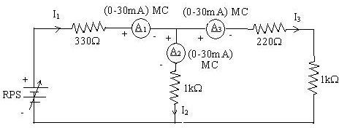

KCL - Practical Values:

Sl. No. | Voltage E | Current |  |  | I1 = I2 + I3
 |  | I1 | I2 | I3
 | Volts | mA | mA | mA | mA
1 | 5 | 5.68 | 3.12 | 2.56 | 5.68
2 | 15 | 17.1 | 9.37 | 7.68 | 17.1
3 | 25 | 28.4 | 15.6 | 12.8 | 28.4

Procedure for KVL:

- Give the connections as per the circuit diagram.

- Set a value in RPS.

- Note all the voltage reading

- Repeat the same for different voltages

Circuit - KVL
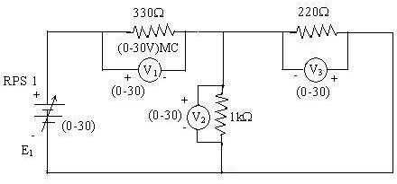

KVL - Practical Values

Sl. No. | RPS | Voltage |  |  | E1 = V1 + V2
 | E1 | V1 | V2 | V3
 | V | V | V | V | V
1 | 5 | 3.23 | 1.77 | 1.77 | 5
2 | 10 | 6.47 | 3.53 | 3.53 | 10
3 | 15 | 9.7 | 5.3 | 5.3 | 15

Result:
Thus, Kirchhoff’s voltage law and Kirchhoff’s current law are verified practically by performing this experiment.

Post Lab Questions

1. Define Kirchhoff’s current law.
Kirchhoff’s Current Law states that the total current coming into a junction is equal to the total current going out of that junction.
It is based on the principle of conservation of charge.
This means no charge is lost at any node in a circuit.

2. Define Kirchhoff’s voltage law.
Kirchhoff’s Voltage Law states that the total voltage in a closed loop is equal to zero.
In other words, the sum of voltage supplied is equal to the sum of voltage drops.
It is based on the law of conservation of energy.

3. What are the applications of regulated power supply?
A regulated power supply is used to give a constant and stable voltage to electronic devices.
It is commonly used in computers, mobile chargers, and laboratory equipment.
It also helps protect circuits from changes in voltage.

4. What are the limitations of KCL?
KCL is not fully accurate at very high frequencies.
It does not take electromagnetic effects into account.
It assumes that no energy is stored at the junction.

